**Udemy Url -** [**Notebook**](https://notebook.zohopublic.in/public/notes/dcr5z12bd30d9fbc2454e9881904115682227)

**Aspect Oriented Programming** (AOP) compliments OOPs in the sense that it also provides modularity. But the key unit of modularity is aspect than class.

AOP breaks the program logic into distinct parts (called concerns). It is used to increase modularity by **cross-cutting concerns**.

A **cross-cutting concern** is a concern that can affect the whole application and should be centralized in one location in code as possible, such as transaction management, authentication, logging, security etc.

**AOP is a programming paradigm that aims to increase modularity by allowing the separation of cross-cutting concerns.** It does this by adding additional behavior to existing code without modifying the code itself.

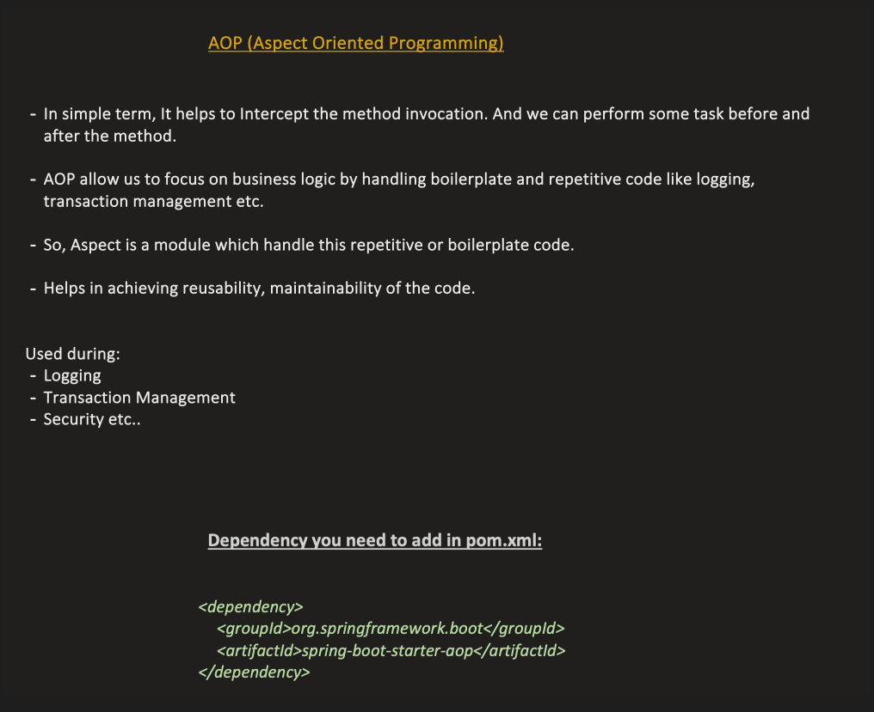

AOP Concepts and Terminology

Join point

Join point is any point in your program such as method execution, exception handling, field access etc. Spring supports only method execution join point. This represents a point in your application where an aspect can be applied.

Advice

Advice represents an action taken by an aspect at a particular join point. There are different types of advices:

* **Before Advice**: it executes before a join point.
* **After Returning Advice**: it executes after a joint point completes normally.
* **After Throwing Advice**: it executes if method exits by throwing an exception.
* **After (finally) Advice**: it executes after a join point regardless of join point exit whether normally or exceptional return.
* **Around Advice**: It executes before and after a join point.

Pointcut

It is an expression language of AOP that matches join points. Pointcuts help determine where advice should be applied.

Introduction

It means introduction of additional method and fields for a type. It allows you to introduce new interface to any advised object.

Target Object

It is the object i.e. being advised by one or more aspects. It is also known as proxied object in spring because Spring AOP is implemented using runtime proxies.

Aspect

It is a class that contains advices, joinpoints etc.

Interceptor

It is an aspect that contains only one advice.

AOP Proxy

It is used to implement aspect contracts, created by AOP framework. It will be a JDK dynamic proxy or CGLIB proxy in spring framework. This is an object created after applying aspects to a target object. In Spring AOP, proxies are JDK dynamic proxies or CGLIB proxies that ensure that the execution of advice takes place when the target object’s methods are invoked.

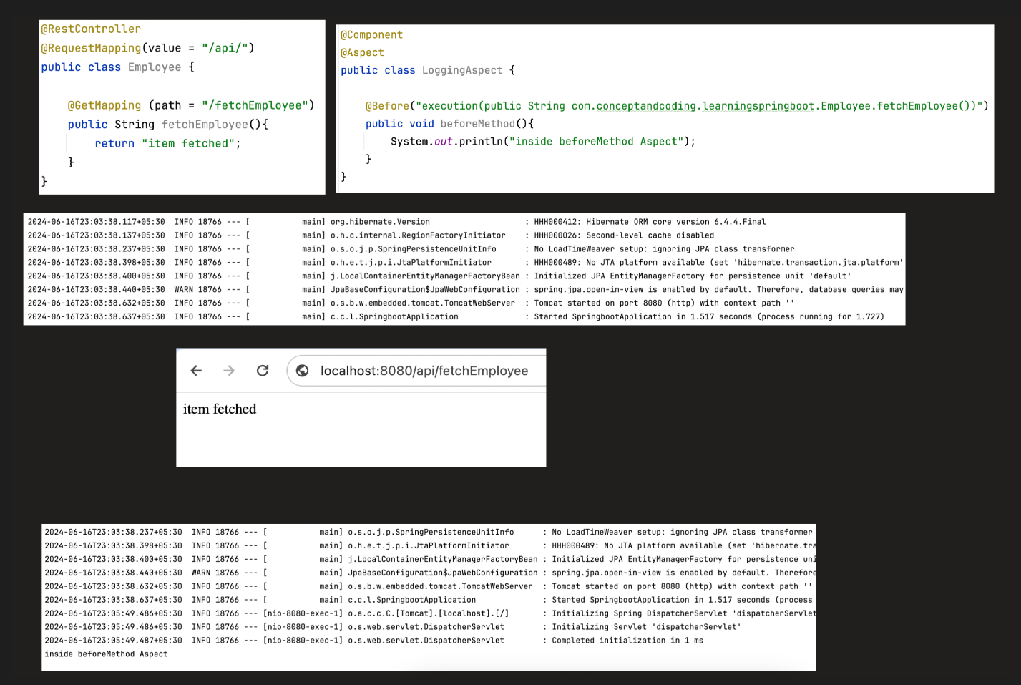

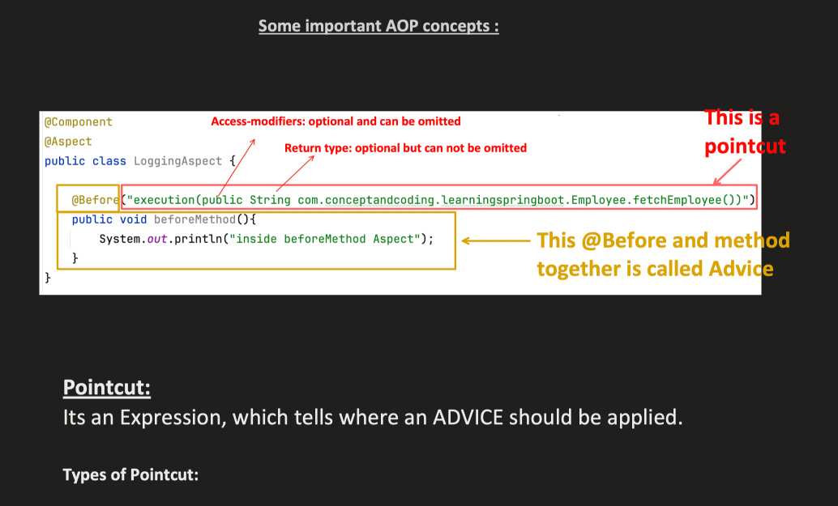

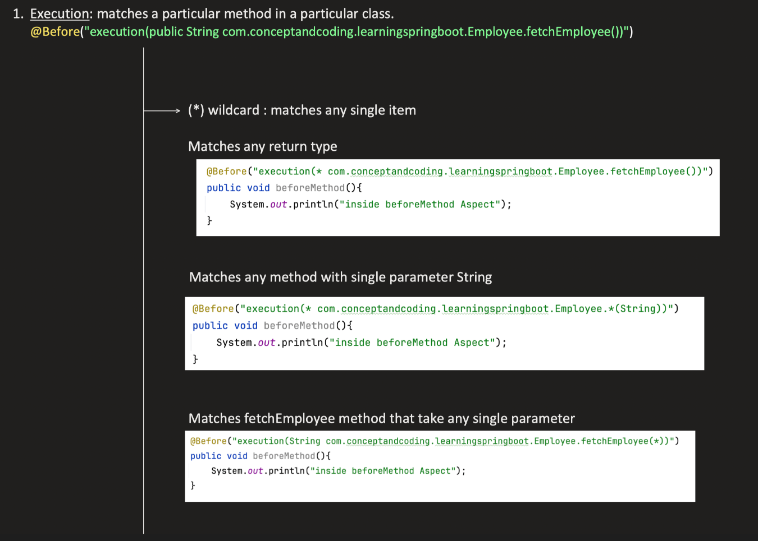

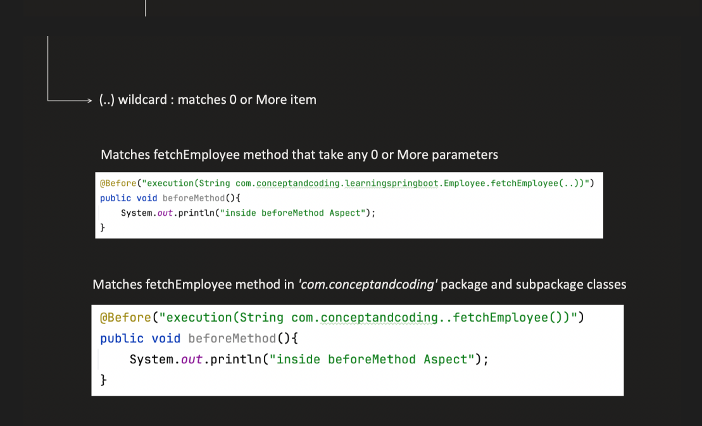

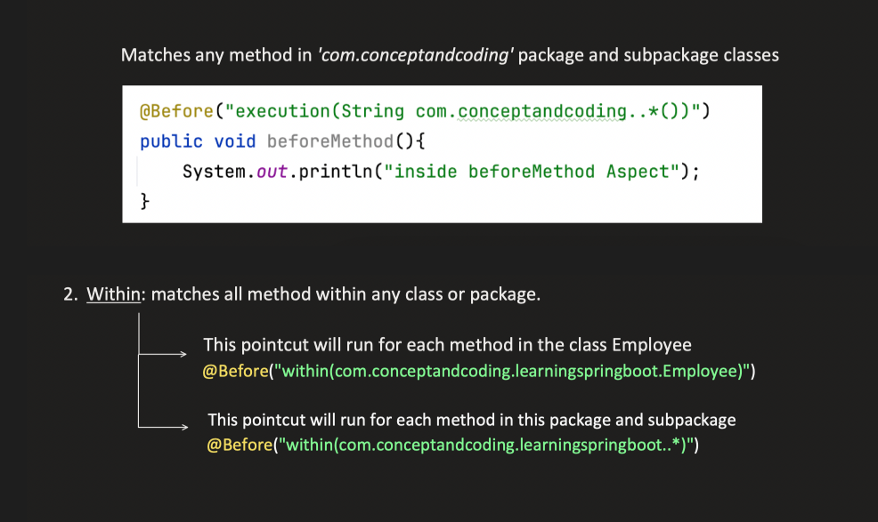

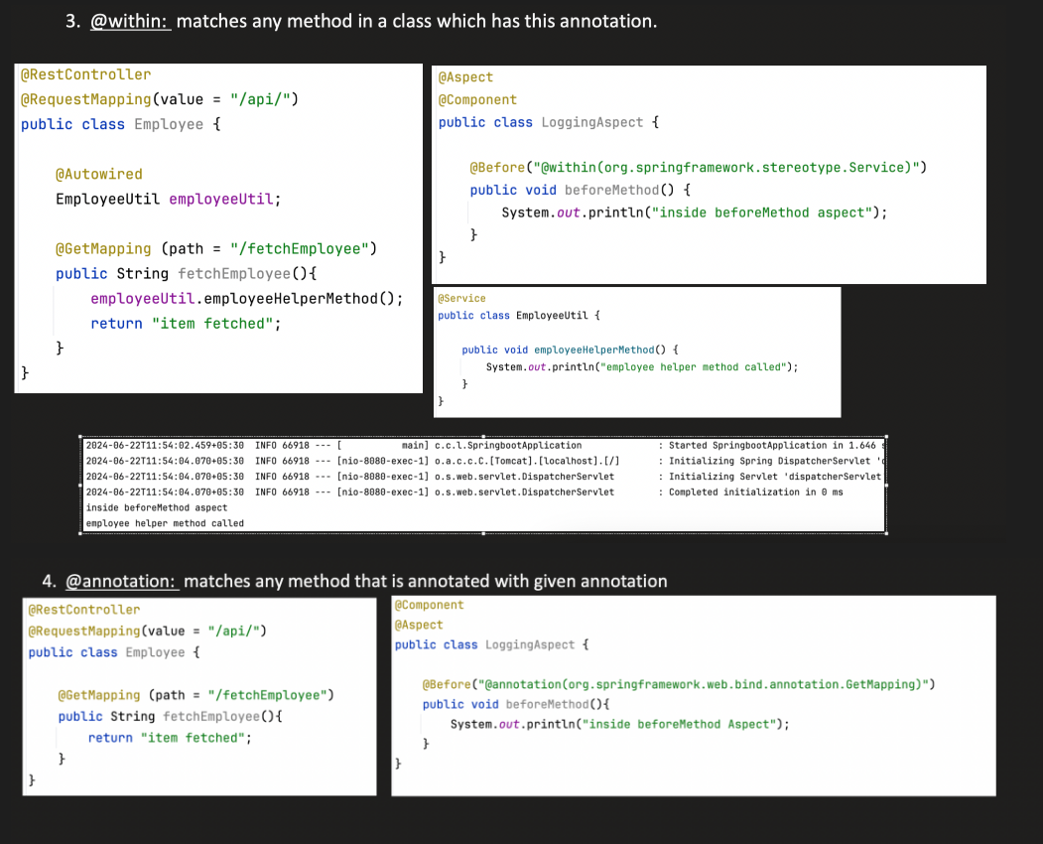

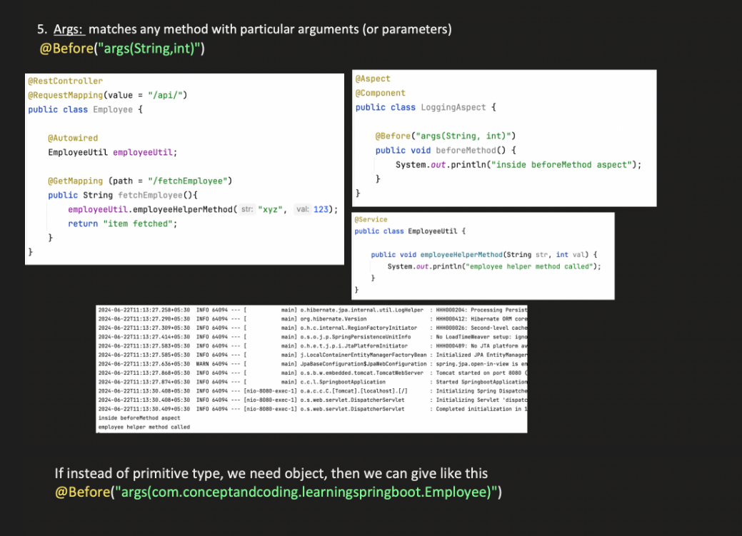

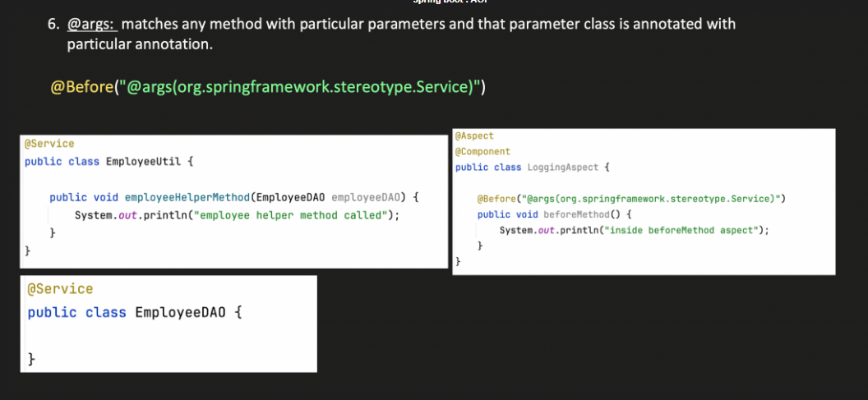

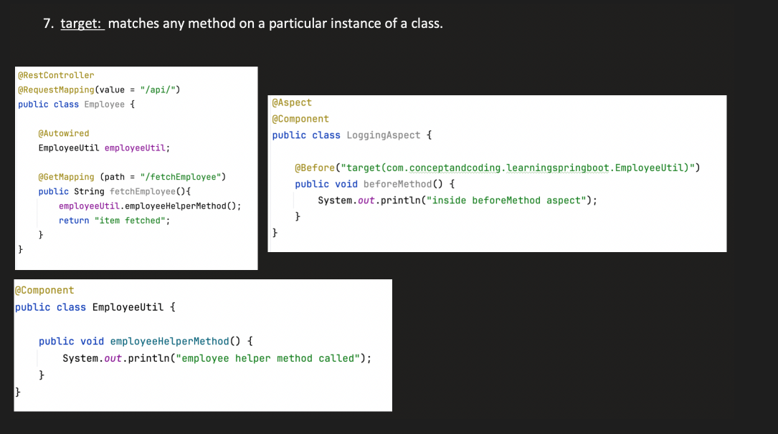

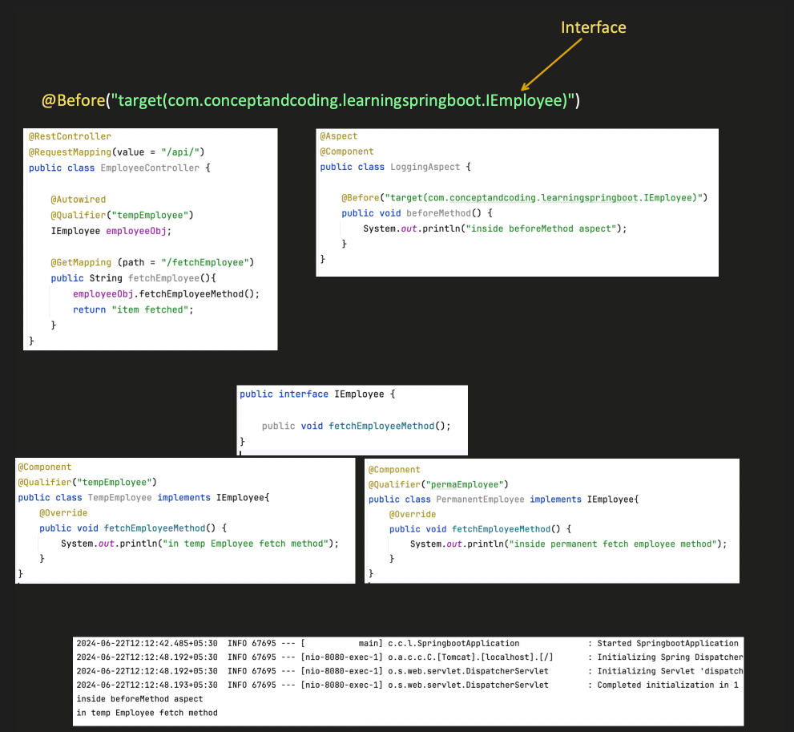

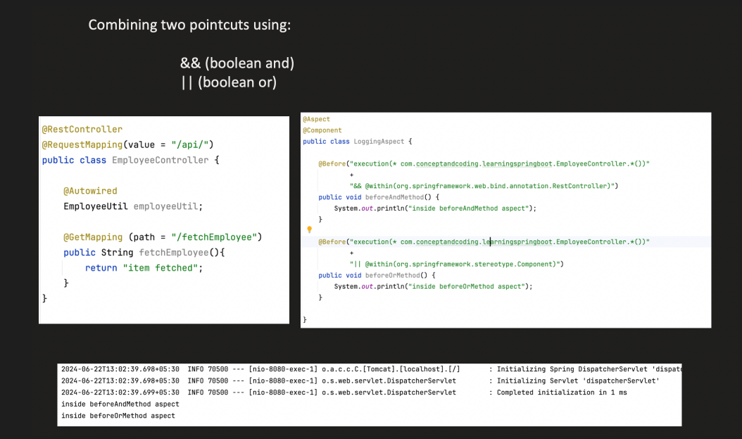

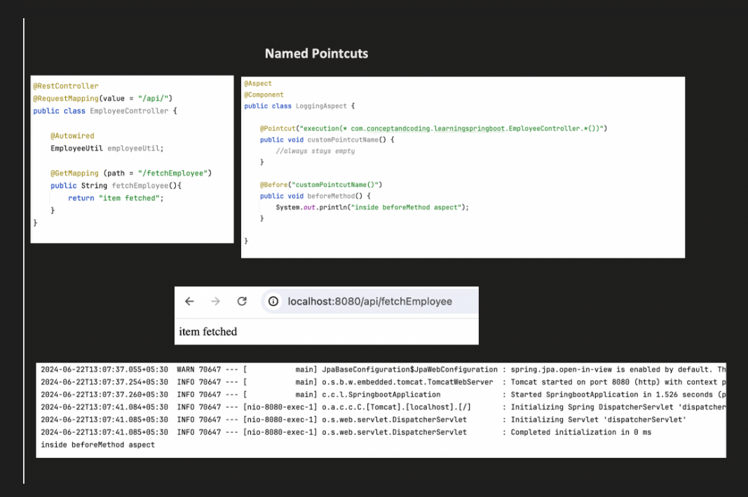

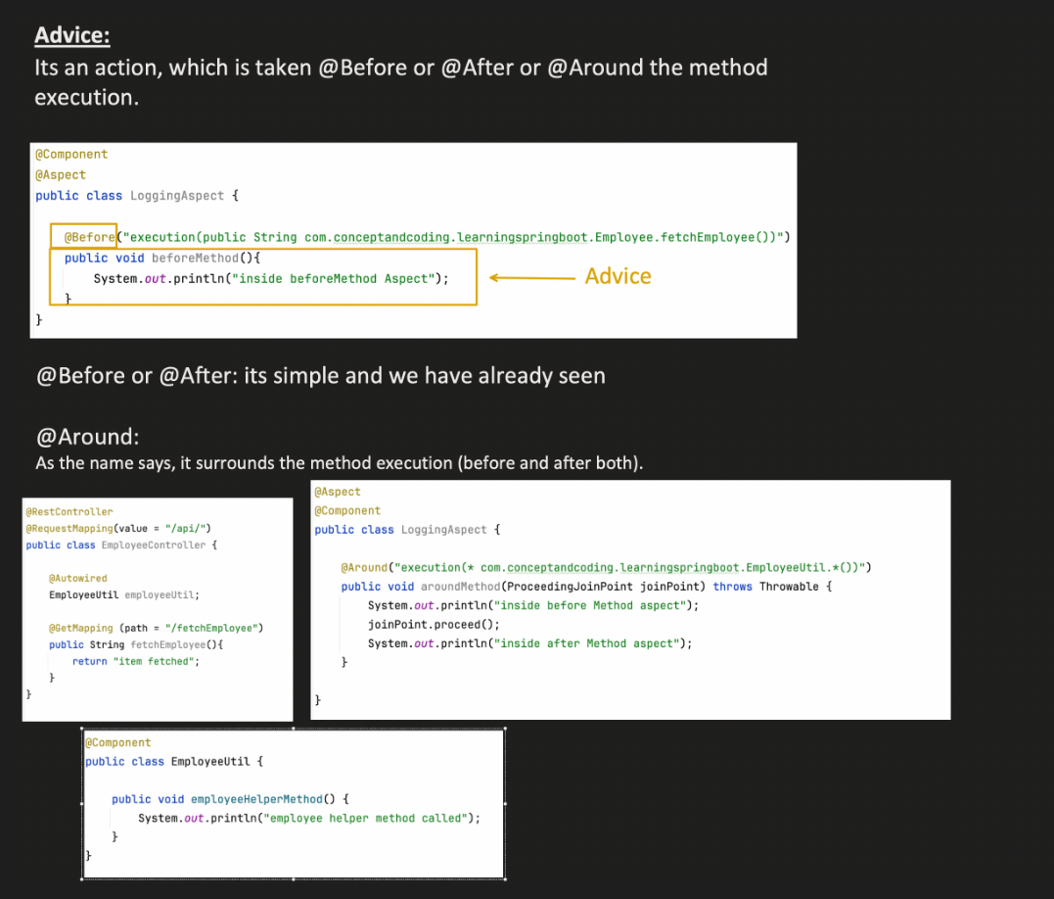

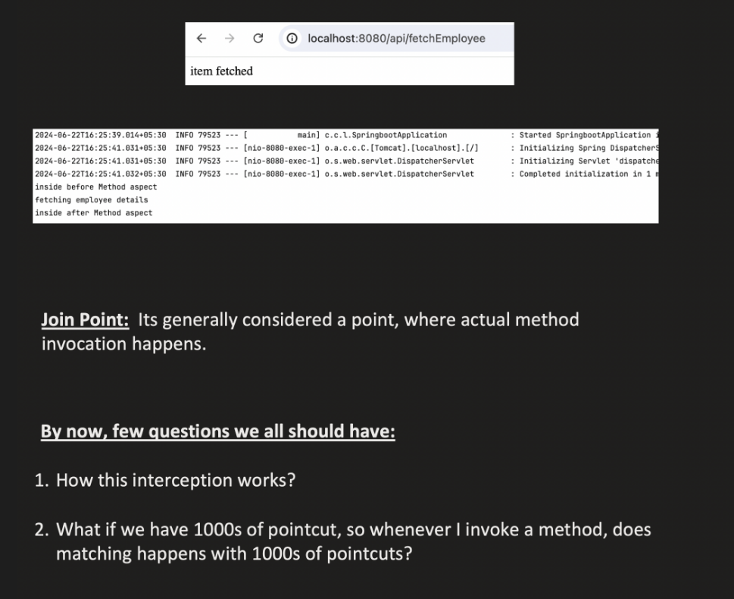

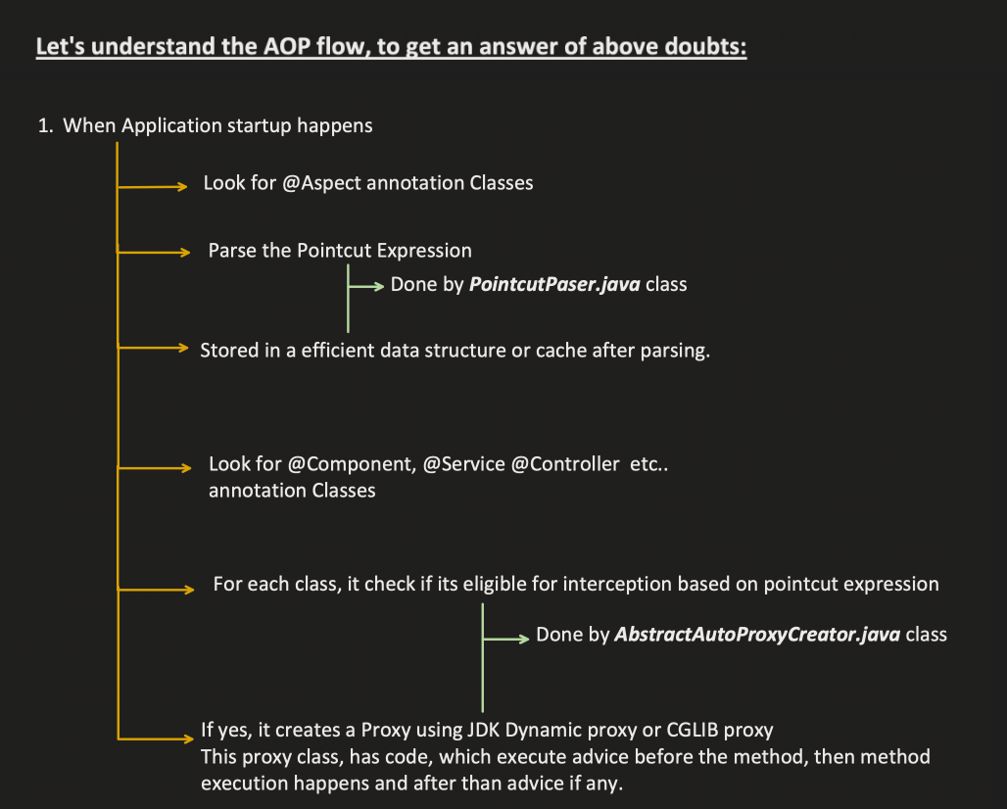

At Bean Creation Time (Context Initialization)

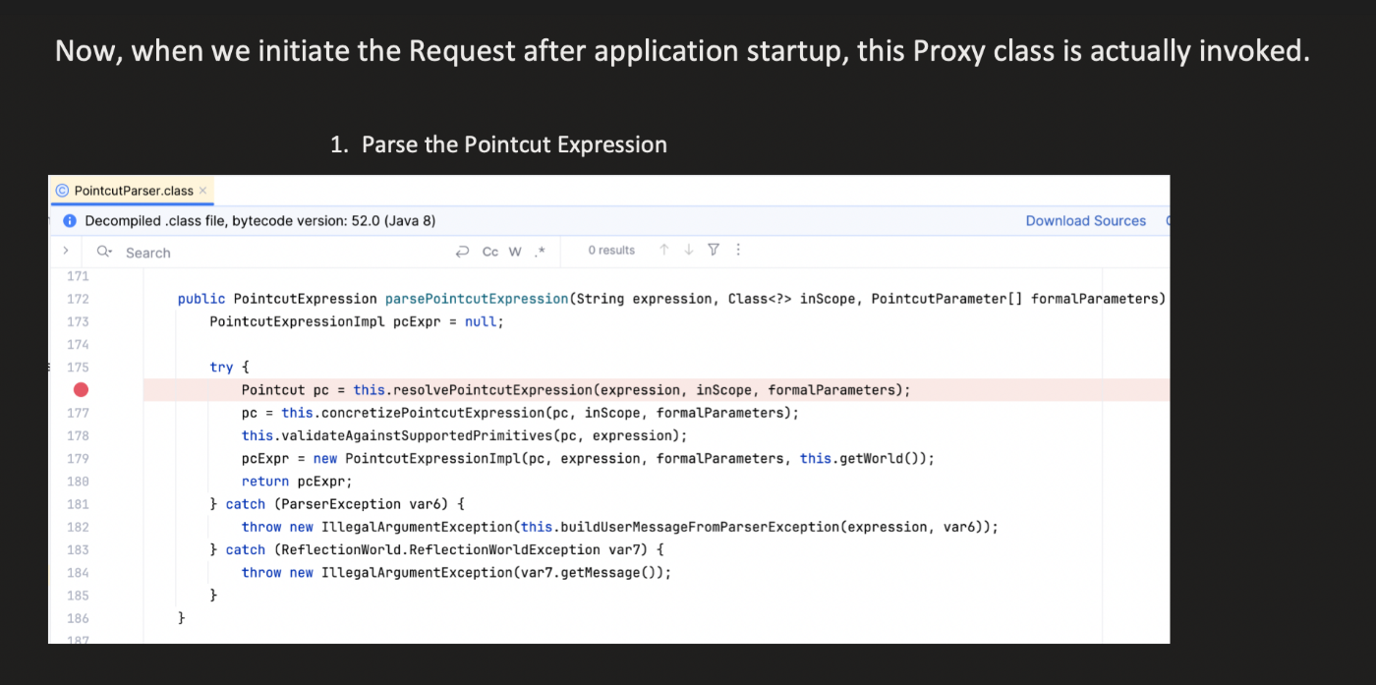

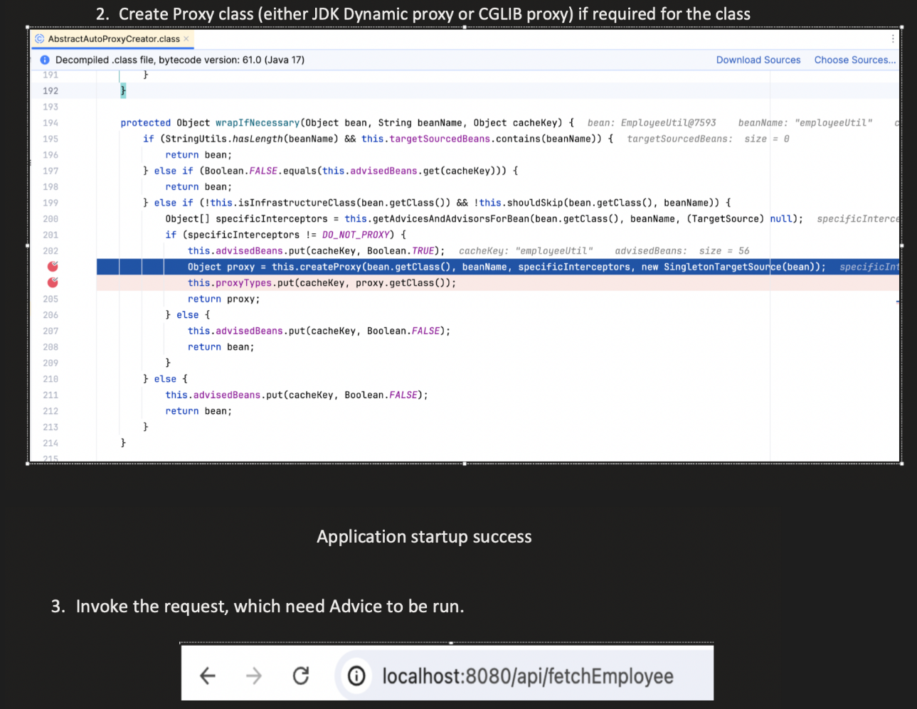

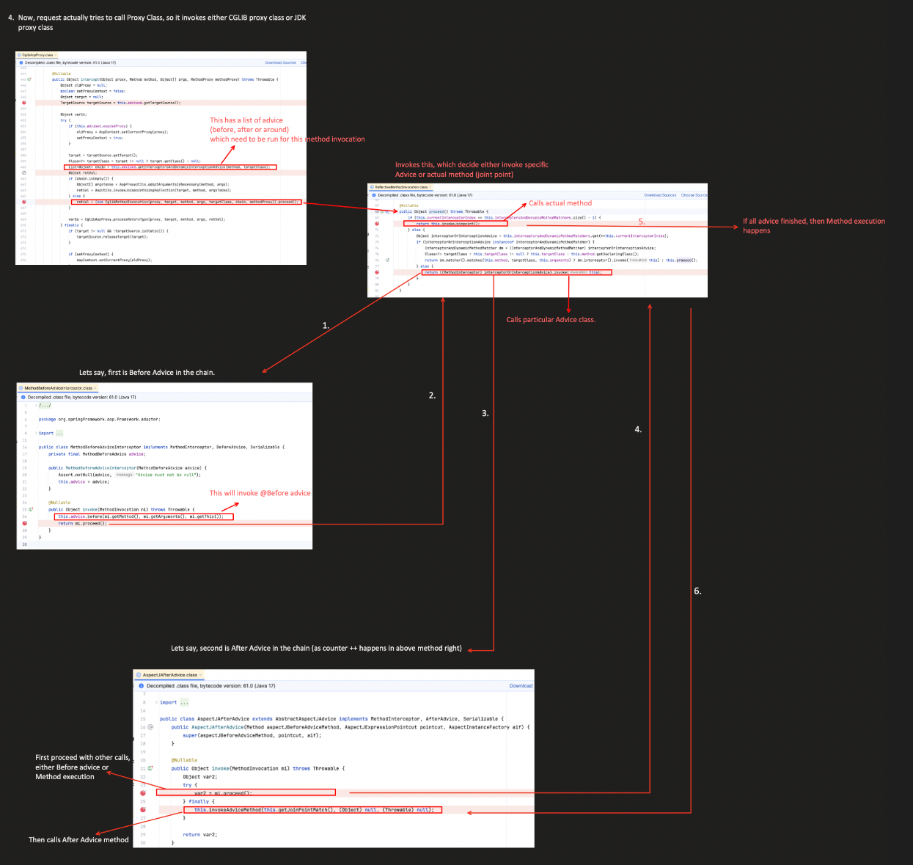

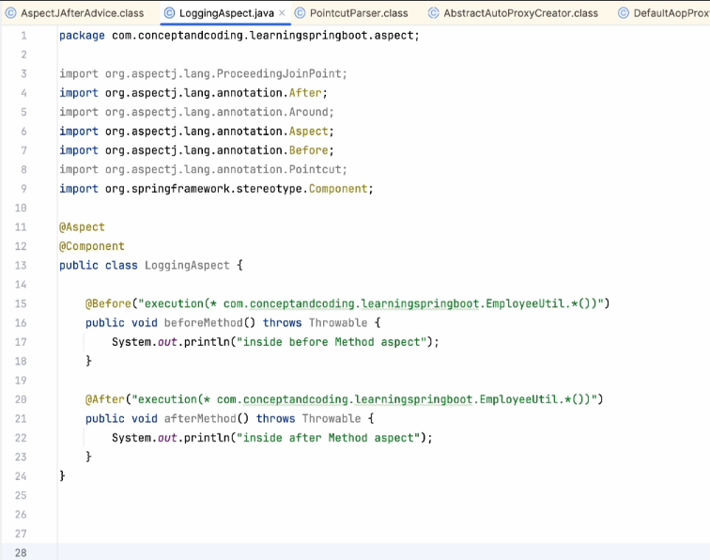

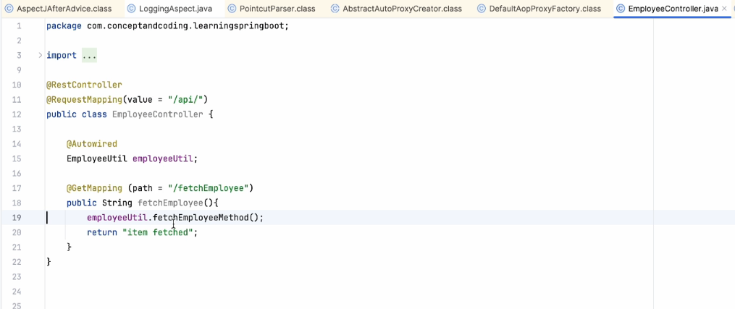

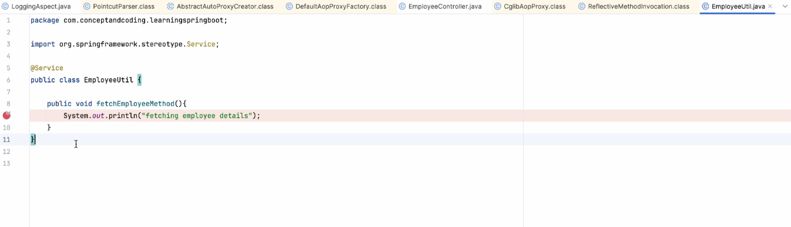

Here the pointcut matches but instead of calling above class it will create the proxy class of this and invoke the CGLIB(code generation library) proxy method(bcz this class does not implement any interface. If implement any interface it will use jdk proxy)

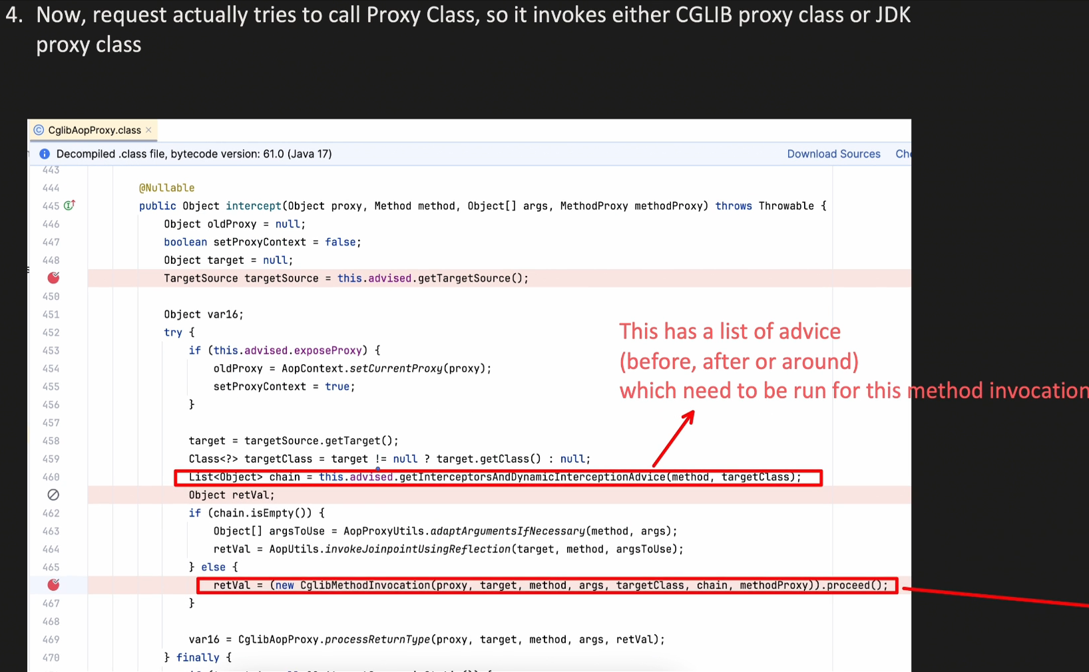

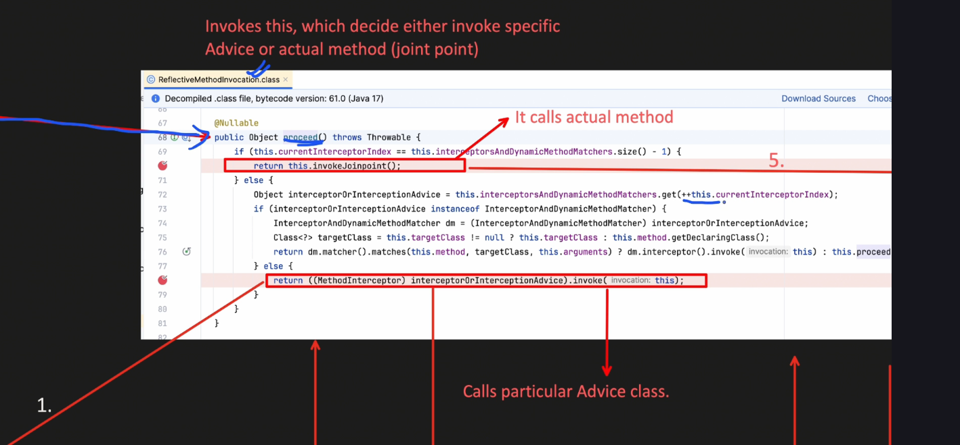

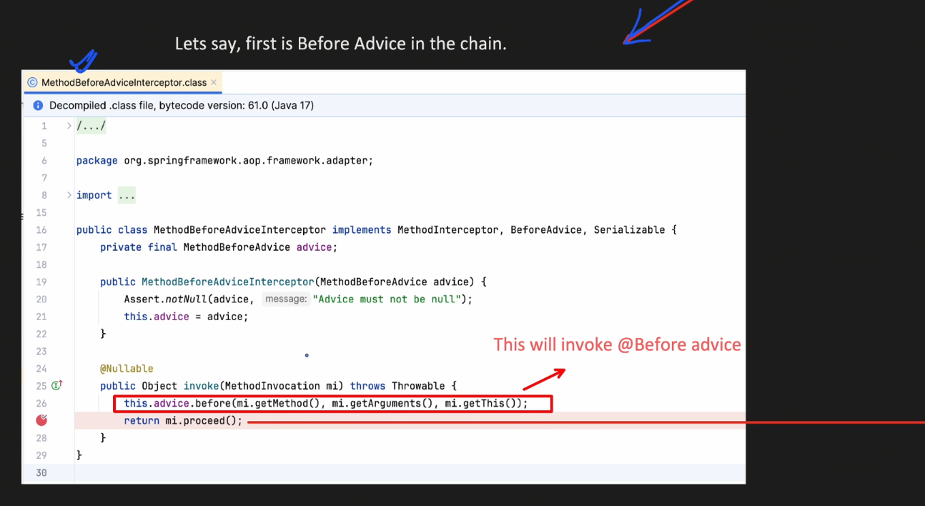

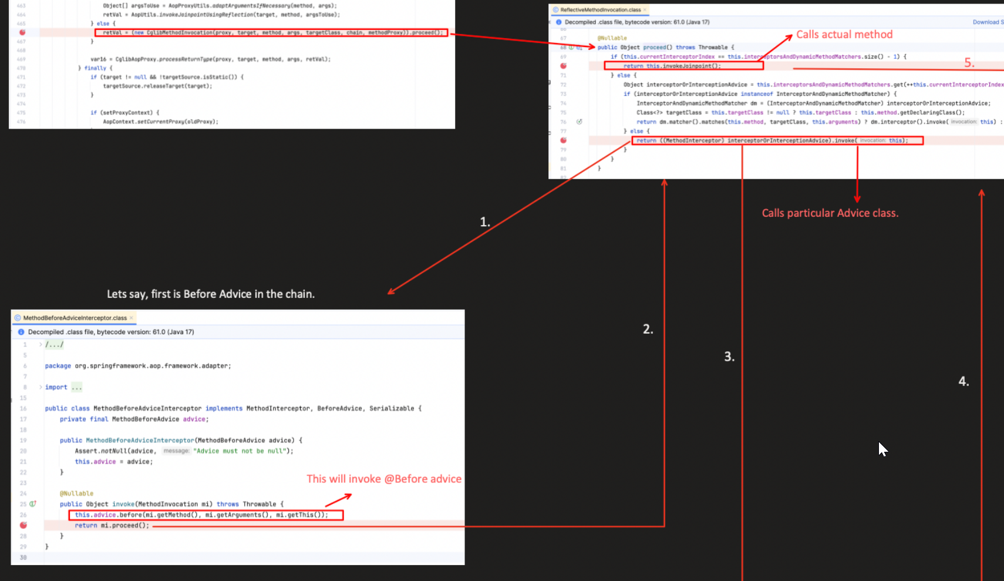

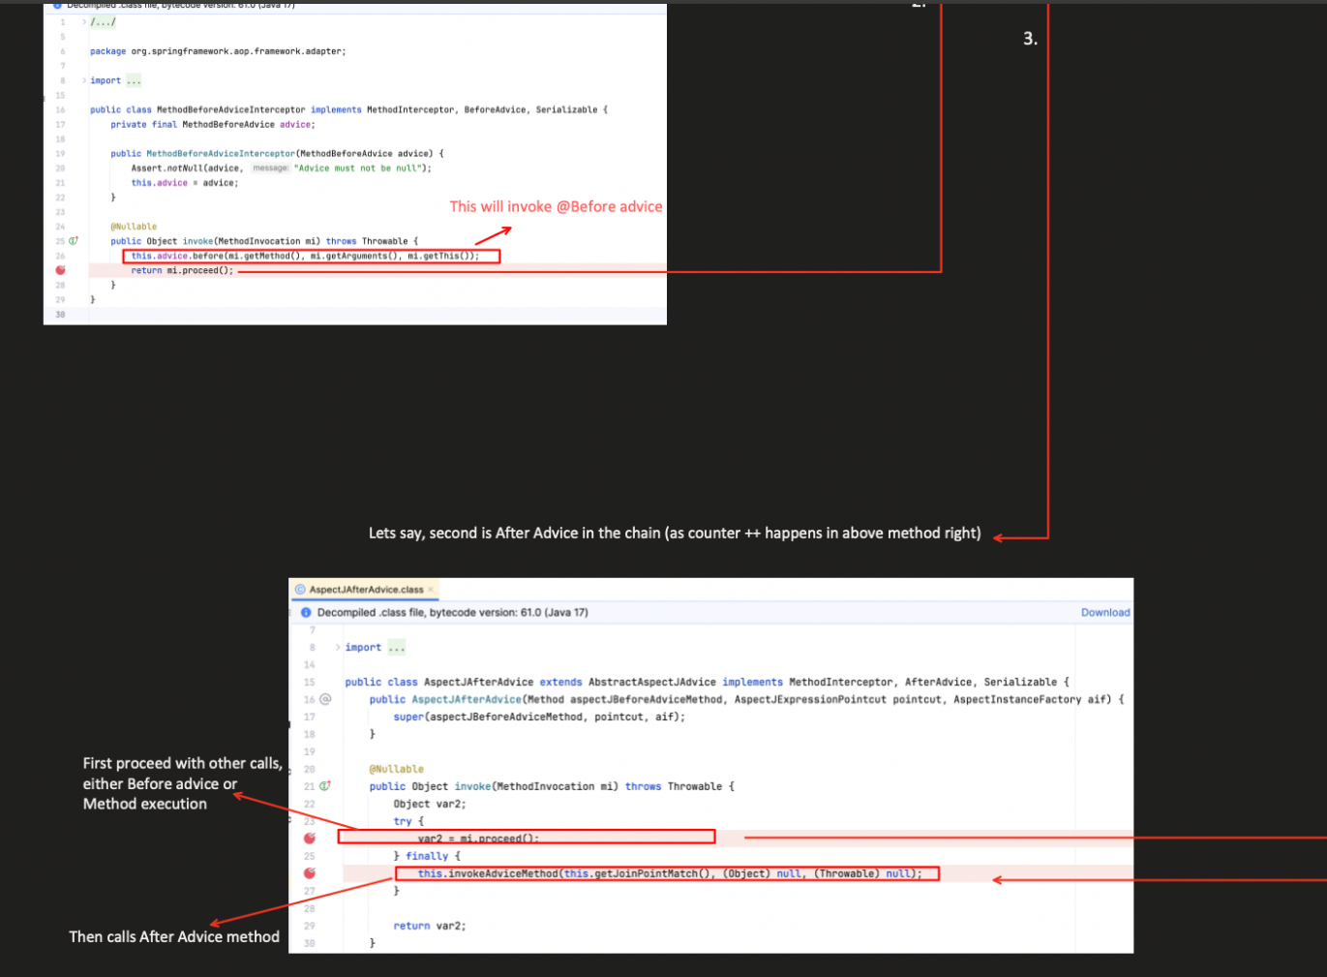

**🔄 2. At Method Call Time (Runtime Execution)**

**What happens here?**

* You are actually calling a **proxy object** (OrderService$$EnhancerBySpringCGLIB).
* The proxy intercepts the method call.
* It looks at the advice chain set up earlier during bean creation.
* It executes the advice (e.g., @Before, @Around, etc.).
* Then it proceeds to the actual method (unless the advice decides to block it).

✅ This is when the **advice is actually executed**, not the pointcut.

# ✅ Scenario Setup

We’ll work with this simple setup:

**OrderService.java**

@Service

public class OrderService {

public void placeOrder() {

System.out.println("Order placed.");

}

}

**LoggingAspect.java**

@Aspect

@Component

public class LoggingAspect {

@Before("execution(* com.example.OrderService.*(..))")

public void logBefore(JoinPoint joinPoint) {

System.out.println("Before method: " + joinPoint.getSignature().getName());

}

}

**🔍 Visual Walkthrough**

**🔸 Step 1: Spring Context Initialization (Bean Creation Time)**

@SpringBootApplication

public class DemoApp {

public static void main(String[] args) {

ApplicationContext ctx = SpringApplication.run(DemoApp.class, args);

OrderService orderService = ctx.getBean(OrderService.class);

}

}

▶ What happens during SpringApplication.run()?

┌────────────────────────────────────────────────────┐

│ Spring Bean Post-Processing Begins │

└────────────────────────────────────────────────────┘

│

▼

Finds @Aspect class → `LoggingAspect`

│

▼

Parses pointcut → "execution(* com.example.OrderService.*(..))"

│

▼

Scans all beans (OrderService matches this pointcut)

│

▼

Replaces OrderService bean with a **CGLIB proxy**

│

▼

Attaches `logBefore()` advice to proxy method `placeOrder()`

✅ **Pointcut is evaluated here**, during this bean processing phase.

**🔸 Step 2: Method Call at Runtime**

orderService.placeOrder();

▶ What happens when you call the method?

┌─────────────────────────────────────┐

│ Calling Proxy Object Method │

└─────────────────────────────────────┘

│

▼

Proxy intercepts call to `placeOrder()`

│

▼

Matches previously attached advice: `logBefore()`

│

▼

Executes advice → logs method name

│

▼

Executes actual method → "Order placed."

✅ **Advice is executed at method call time.**

🔥 **What happens when an @Before advice is declared on a @RequestScope bean?**  
i.e., what if your **aspect is defined inside a request-scoped bean**, and it's used for AOP?

**⚠️ Short Answer:**

**It won’t work as expected unless scoped proxying is enabled**, and even then, it’s **not recommended** to use AOP aspects inside @RequestScope beans.

**❓Why?**

**Spring AOP and Aspect Beans must be available at ApplicationContext startup time, during proxy creation.**

If you define an @Aspect inside a @RequestScope bean:

@Component

@Scope(value = WebApplicationContext.SCOPE_REQUEST)

@Aspect

public class RequestScopedAspect {

@Before("execution(* com.example..*(..))")

public void beforeAdvice() {

System.out.println("Request-scoped aspect executing...");

}

}

**Here's What Happens:**

**🔍 Root Cause**

* Spring AOP is **proxy-based**, and all AOP wiring (matching pointcuts, generating proxies, etc.) is done during **startup**, not during HTTP request.
* But @RequestScope beans are **created only per HTTP request**, so they are **not available** at startup.

🔁 So Spring **cannot detect that this is an aspect**, and no proxy is created for the target beans.